11AC 600Mbps
Wireless USB Adapter
WL-700RXS-BT

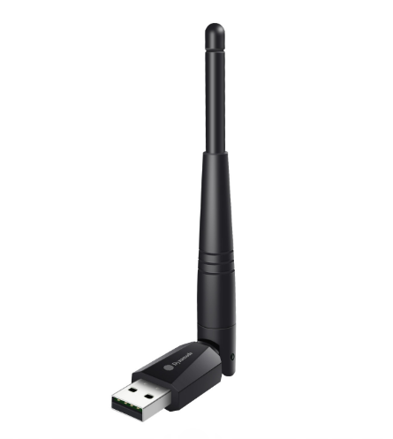

Description
The exciting WL-700-ART-AC3 is a new generation of high performance, 802.11ac USB wireless adapters that's ideal for the next generation of applications including 4K HD streaming, online gaming as well as super-fast web browsing and other Internet activities.
Featuring a high-gain antenna that provides additional transmit and receive WiFi power compared with lesser models, the WL-700-ART-AC3 is ideal for Windows(tm) and Mac(tm) OS X operating systems with total Plug n' Play setup.

Features
- Dual-band 802.11AC WiFi
- Automatic 2.4Ghz or 5Ghz for less congestion
- Super-fast, up to 600Mbps WiFi performance
- Integral, high-gain antenna for better connections
- Ideal for the latest Broadband routers and Mesh WLANs
- Plug n' Play for Windows(tm), Mac(tm) OS X and Linux(tm)

SPECIFICATIONS
WIFI Feature
Standards | IEEE 802.11ac,IEEE 802.11a, IEEE 802.11n, IEEE 802.11g, IEEE 802.11b
Wireless Signal  Rates With  Automatic Fallback | 11ac: Up to 433Mbps(Dynamic)  11n: Up to 150Mbps (Dynamic)  11g: Up to 54Mbps (Dynamic)  11b: Up to 11Mbps (Dynamic)
Chipset | RTL8811CU
Frequency Range | 2.4-2.4835GHz/5.15-8.825GHz
Wireless Transmit Power | 20dBm (EIRP)
Modulation Type | DBPSK,DQPSK,CCK, OFDM, 256QAM
Receiver Sensitivity | 433M: -61dBm@10% PER  150M: -72dBm@10% PER  54M: -72dBm@10% PER  11M: -85dBm@8% PER
Work Mode | Ad-Hoc Infrastructure
Wireless Security | WPS,64/128bit WEP,WPA/WPA2,WPA-PSK/WPA2-PSK(TKIP/AES)
Support Operating  System | Windows VISTA/Win7/Win8/Win8.1/Win10/Linux/  Macintosh
Hardware Feature
Interface | USB2.0 Hi-Speed connector
Antenna Type | Fixed antenna
Antenna Gain | 3dBi
Dimensions | 37.5*18*13mm
Other
Package Content | 1PCS OF USB adapter  1PCS OF Setup CD（include User Manual）
Operating Temperature | 0°C~40°C
Storage Temperature | -20°C~60°C
Relative Humidity | 10% ~ 90%, non condensation
Storage Humidity | 5%~95% non-condensing

